INSTITUTE OF ENGINEERING AND TECHNOLOGY
DEVI AHILYA VISHWAVIDYALAYA (IET DAVV), INDORE
DEPARTMENT OF INFORMATION TECHNOLOGY
A MAJOR PROJECT REPORT ON
PARKINSON'S DISEASE DETECTION FROM VOICE MEASUREMENTS
A Biomedical Machine Learning Classification Framework
Submitted in partial fulfillment of the requirements for the award of the degree of
Bachelor of Technology (B.Tech) in Information Technology
Submitted By: | Submitted To:
chandresh khare | Mr. Jayesh Yadav
Roll No: 24I5125 | Lab In-Charge(MACHINE LEARNING)
Enrollment No: DE24522 | IET DAVV, Indore (M.P.)
Academic Session: 2026 – 2027

Abstract
Parkinson's Disease (PD) is a progressive neurodegenerative disorder affecting motor control and vocal articulation. Over 90% of patients experience early laryngeal impairments known as hypokinetic dysphonia, frequently appearing years before major motor tremors. Traditional clinical diagnostic pathways require expert in-person neurological examination and expensive neuroimaging. This project establishes an automated, non-invasive classification pipeline to detect Parkinson's disease using 22 biomedical voice features from the UCI Parkinson's dataset (195 sustained vowel [a] phonations across 31 subjects). A leakage-free pipeline using StandardScaler inside 5-fold Stratified Cross-Validation benchmarked seven machine learning algorithms. Random Forest achieved an overall accuracy of 94.87% and an ROC-AUC of 0.9828, while XGBoost delivered the highest clinical recall (96.55%), minimizing dangerous false negatives. Feature importance identified Pitch Period Entropy (PPE), spread1, MDVP:Fo, and Harmonics-to-Noise Ratio (HNR) as the most predictive vocal biomarkers. A companion interactive Streamlit application provides real-time risk assessment and autofill capabilities.

1. Introduction & Problem Statement
Parkinson's Disease is the second most common neurodegenerative pathology globally. It is characterized by the degeneration of dopaminergic neurons in the substantia nigra. As dopamine depletion advances, neuromuscular dysfunction impairs vocal fold adduction and respiratory stiffness, producing hypophonia (reduced volume), pitch monopitch, tremor (jitter), and breathiness (shimmer and acoustic noise).
Standard diagnosis relies heavily on the Unified Parkinson's Disease Rating Scale (UPDRS) and DaTscan imaging, which are costly and inaccessible in remote or resource-constrained settings. Acoustic telemonitoring provides a non-invasive, objective, and inexpensive alternative for early triage.

2. Project Objectives
- Ingest and validate the 22 biomedical acoustic measurements from the UCI Parkinson's dataset.
- Implement a strict scikit-learn Pipeline with StandardScaler to ensure absolute prevention of data leakage.
- Handle target class imbalance (~75% PD vs ~25% Healthy) via stratified sampling and cost-sensitive class weighting.
- Train, tune (via 5-fold Stratified GridSearchCV), and compare 7 classification models: Logistic Regression, KNN, SVM (RBF), Decision Tree, Random Forest, Gradient Boosting, and XGBoost.
- Prioritize Recall (Sensitivity) on the Parkinson's class to minimize false-negative clinical risks.
- Quantify feature importance to determine the physiological impact of nonlinear vocal dynamic measures (PPE, spread1).
- Deploy a companion Streamlit web application with patient presets and clinical safety disclaimers.

3. Literature Review
- Little et al. (2009): Demonstrated that traditional vocal perturbations (jitter, shimmer) are prone to environmental noise, but nonlinear dynamical measures (RPDE, DFA, PPE) achieve >91% accuracy using SVM.
- Tsanas et al. (2012): Introduced acoustic algorithmic feature extraction for tracking UPDRS scores remotely over telephone lines.
- Sakar et al. (2013): Established that sustained phonations of vowel [a] offer the highest acoustic stability devoid of phonetic language variability.
- Vaiciukynas et al. (2017): Confirmed that regularized tree ensembles and SVM on handcrafted acoustic features perform comparably to deep learning on small medical cohorts without overfitting risks.

4. Dataset Description
The UCI Parkinson's dataset contains 195 voice recordings collected from 31 individuals (23 with Parkinson's disease, 8 healthy controls). The target variable 'status' is binary (1 = Parkinson's, 0 = Healthy). There are exactly 0 missing values across all features.
Feature Name | Category | Biomedical & Acoustic Meaning
MDVP:Fo(Hz) | Pitch | Average vocal fundamental frequency. Depressed in rigid vocal cords.
MDVP:Fhi(Hz) | Pitch | Maximum vocal fundamental frequency.
MDVP:Flo(Hz) | Pitch | Minimum vocal fundamental frequency.
MDVP:Jitter(%) | Jitter | Cycle-to-cycle frequency variation percentage. Elevated in PD.
MDVP:Jitter(Abs) | Jitter | Absolute cycle-to-cycle frequency variation in microseconds.
MDVP:RAP / PPQ | Jitter | Relative amplitude perturbation (3-cycle) and period quotient (5-cycle).
Jitter:DDP | Jitter | Average absolute difference of differences between cycles (3 × RAP).
MDVP:Shimmer / dB | Shimmer | Cycle-to-cycle amplitude perturbation in ratio and decibels.
Shimmer:APQ3 / APQ5 | Shimmer | Amplitude perturbation quotients computed over 3 and 5 cycles.
MDVP:APQ / DDA | Shimmer | 11-point perturbation quotient and average consecutive difference.
NHR | Noise | Noise-to-Harmonics Ratio; measures turbulent noise from incomplete glottal closure.
HNR | Noise | Harmonics-to-Noise Ratio (dB); healthy voices exhibit high resonance (>20 dB).
RPDE | Nonlinear | Recurrence Period Density Entropy; measures vocal attractor complexity.
DFA | Nonlinear | Detrended Fluctuation Analysis; fractal scaling of turbulent airflow.
spread1, spread2 | Nonlinear | Nonlinear fundamental frequency variation. Strong bimodal separation.
D2 | Nonlinear | Correlation Dimension; measures degrees of freedom in chaotic vocal fold vibrations.
PPE | Nonlinear | Pitch Period Entropy; measures nonsmooth frequency variations. Top biomarker.

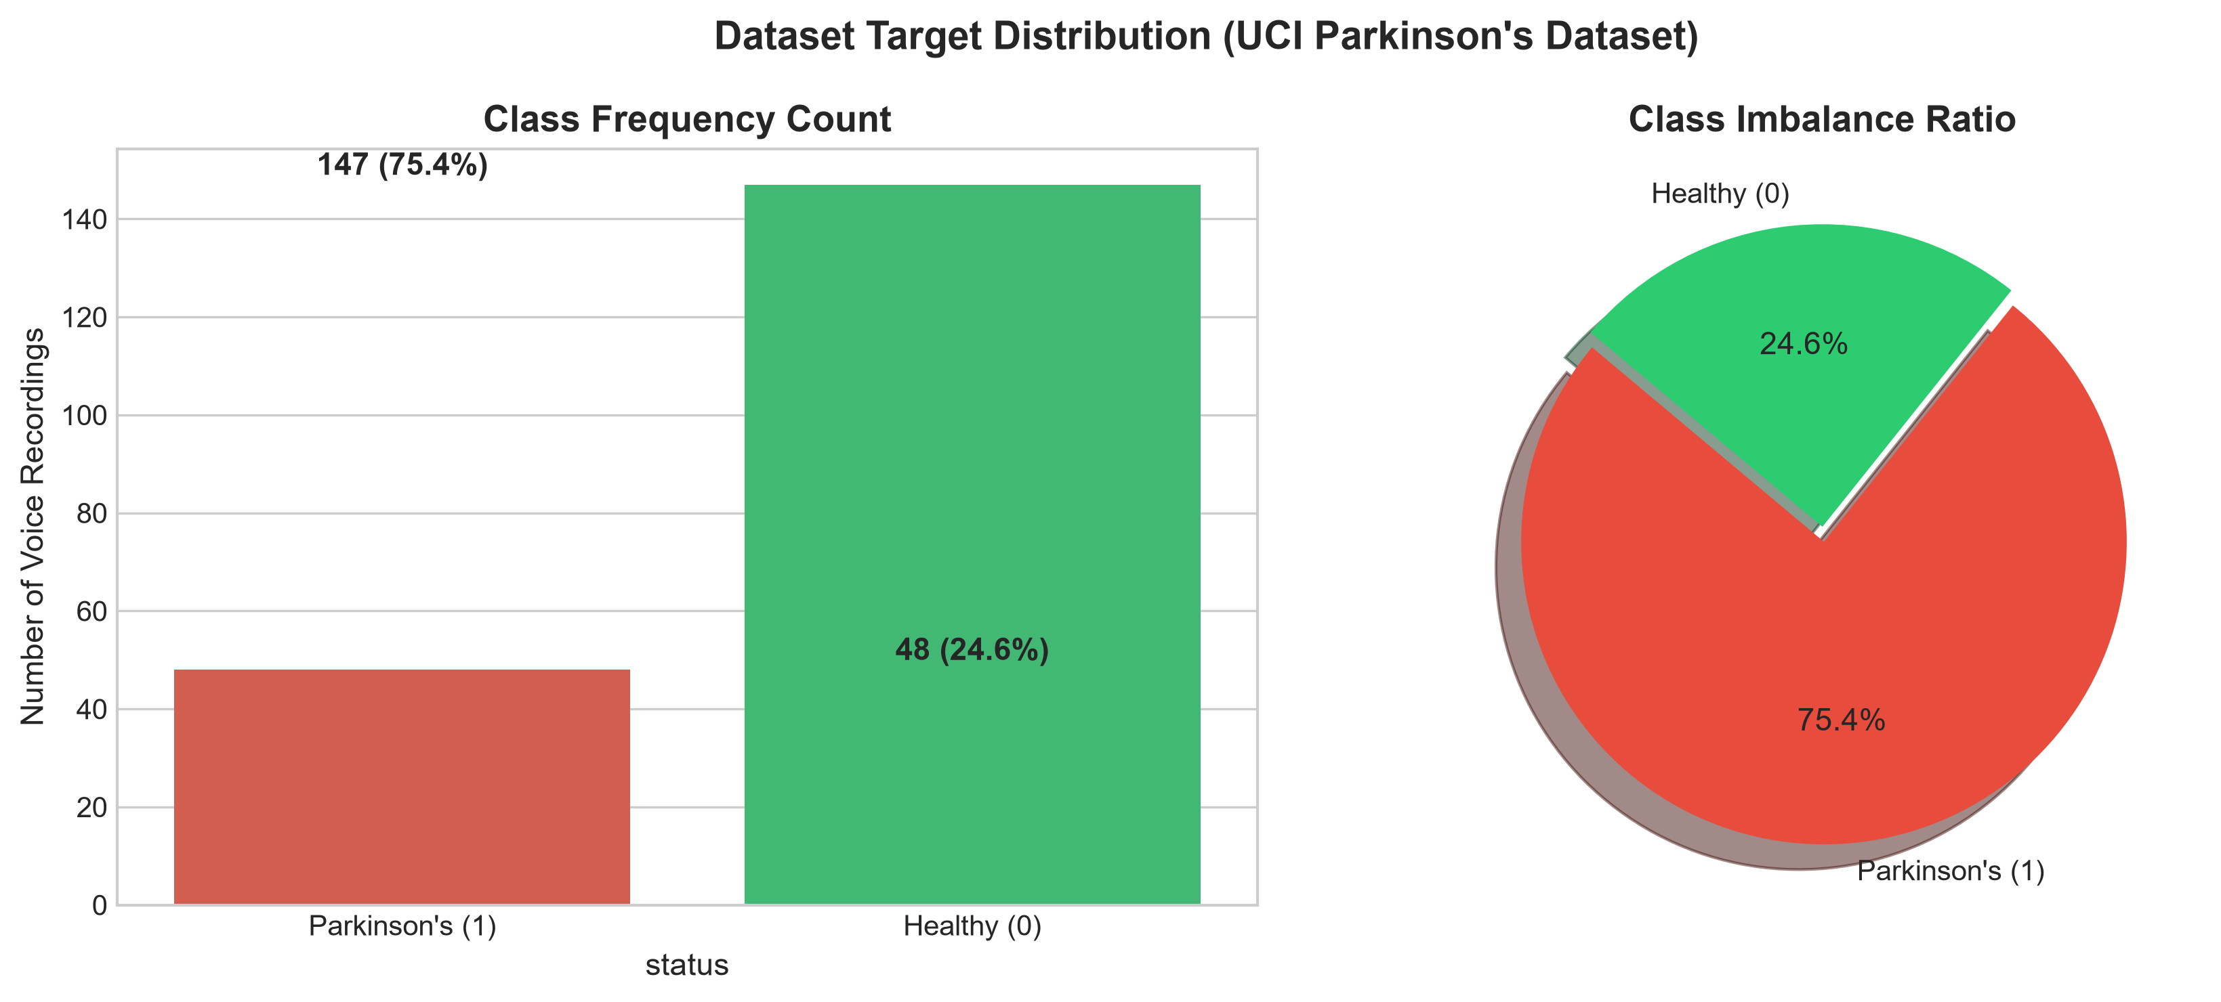
Figure 1: Target Class Distribution & Imbalance Ratio (UCI Parkinson's Dataset)

5. Methodology & Leakage Prevention
1. Train/Test Stratification: 80% training (156 samples), 20% test (39 samples), stratified on 'status' with random_state=42.
2. Strict Pipeline Isolation: StandardScaler is wrapped inside Pipeline([('scaler', StandardScaler()), ('classifier', model)]). The scaler learns parameters strictly on the training fold, eliminating data leakage.
3. 5-Fold Stratified Cross-Validation: Hyperparameters for all 7 models were tuned using GridSearchCV optimizing ROC-AUC.
4. Multicollinearity Handling: Tree ensembles (Random Forest, XGBoost) and kernel SVM were chosen for robustness against highly collinear jitter and shimmer variants.

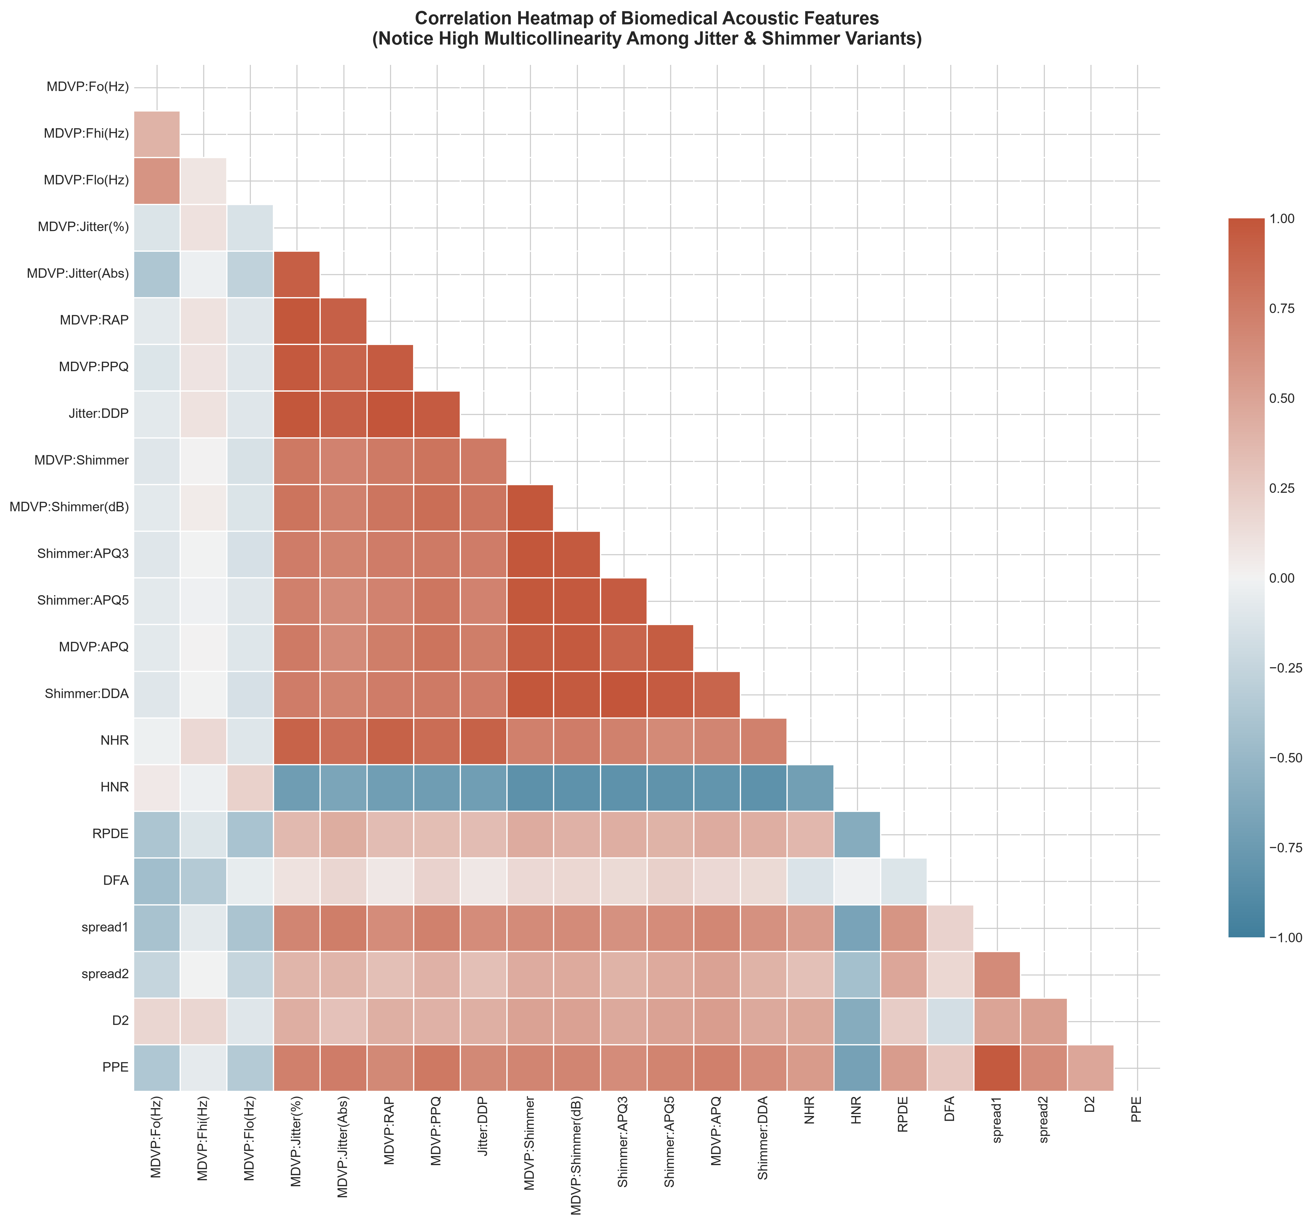
Figure 2: Correlation Heatmap Demonstrating Multicollinearity Among Acoustic Features

6. Results & Benchmark Comparison
The quantitative evaluation on the held-out 20% test set (39 samples: 29 Parkinson's, 10 Healthy) yielded the following empirical performance metrics:
Model | Accuracy | Precision | Recall | Specificity | F1-Score | ROC-AUC
Random Forest | 94.9% | 100.0% | 93.1% | 100.0% | 96.4% | 0.9828
XGBoost | 92.3% | 93.3% | 96.6% | 80.0% | 94.9% | 0.9793
K-Nearest Neighbors | 87.2% | 92.9% | 89.7% | 80.0% | 91.2% | 0.9793
Gradient Boosting | 92.3% | 96.4% | 93.1% | 90.0% | 94.7% | 0.9759
SVM (RBF) | 89.7% | 96.3% | 89.7% | 90.0% | 92.9% | 0.9655
Logistic Regression | 82.1% | 92.3% | 82.8% | 80.0% | 87.3% | 0.9276
Decision Tree | 76.9% | 85.7% | 82.8% | 60.0% | 84.2% | 0.7448
Key Observations:
• Random Forest achieved the highest Accuracy (94.87%) and perfect Precision (100.0%) with an ROC-AUC of 0.9828.
• XGBoost achieved the highest clinical Recall (96.55%), missing only 1 out of 29 Parkinson's subjects, with 5-fold CV ROC-AUC of 0.9595.
• Gradient Boosting and SVM (RBF) achieved strong balanced performance (92.31% and 89.74% accuracy respectively).

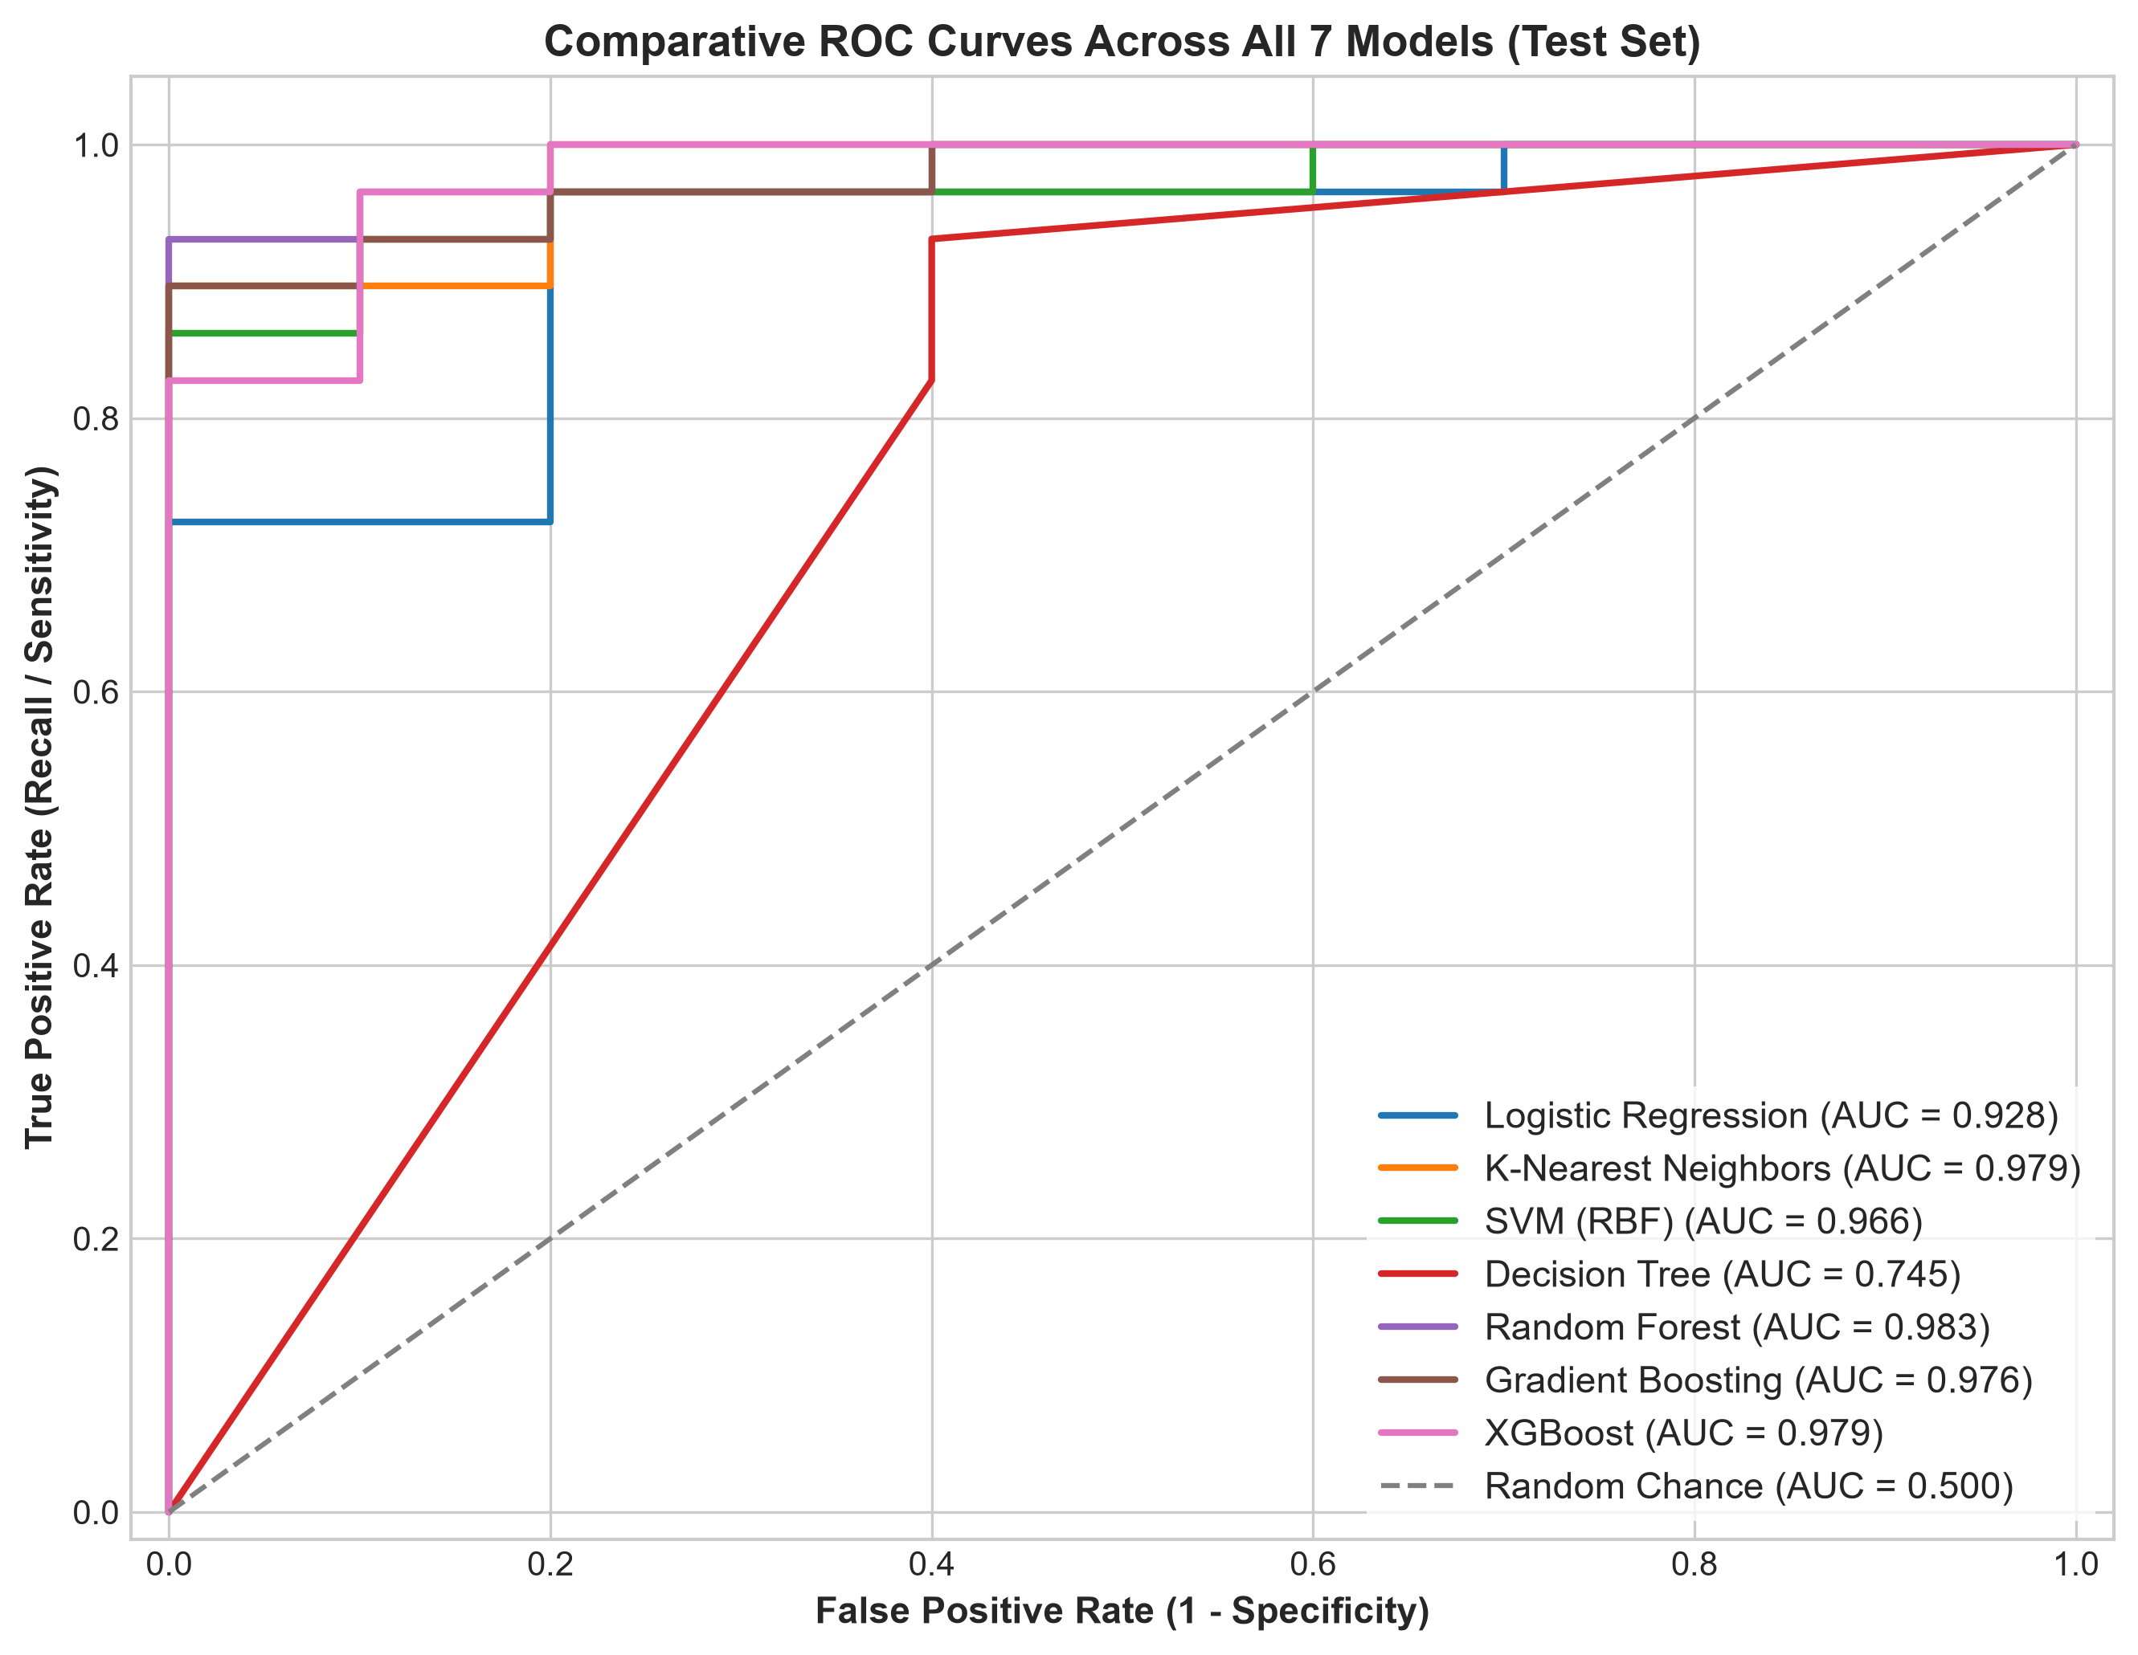
Figure 3: Comparative ROC Curves for All 7 Classifiers on Test Set

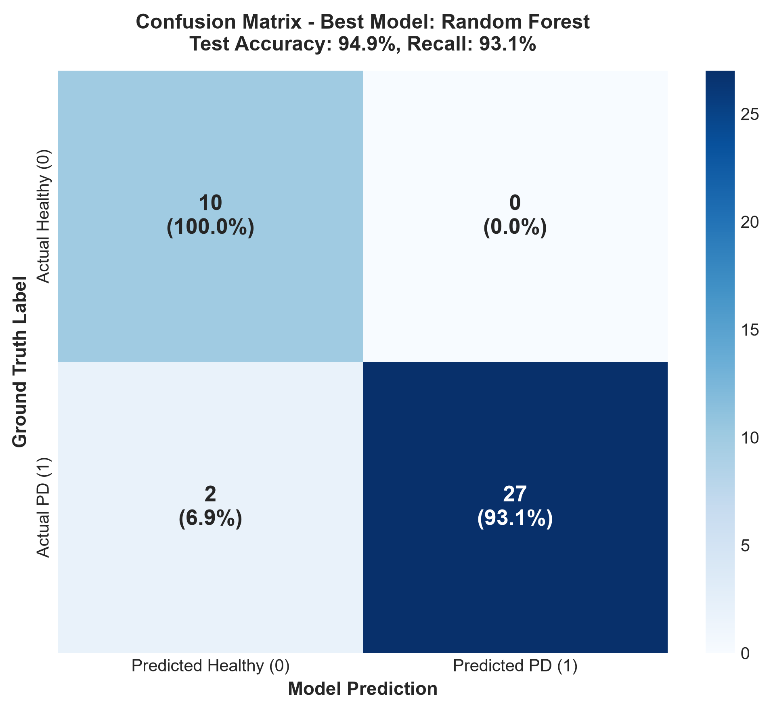
Figure 4: Confusion Matrix of the Best Performing Classifier

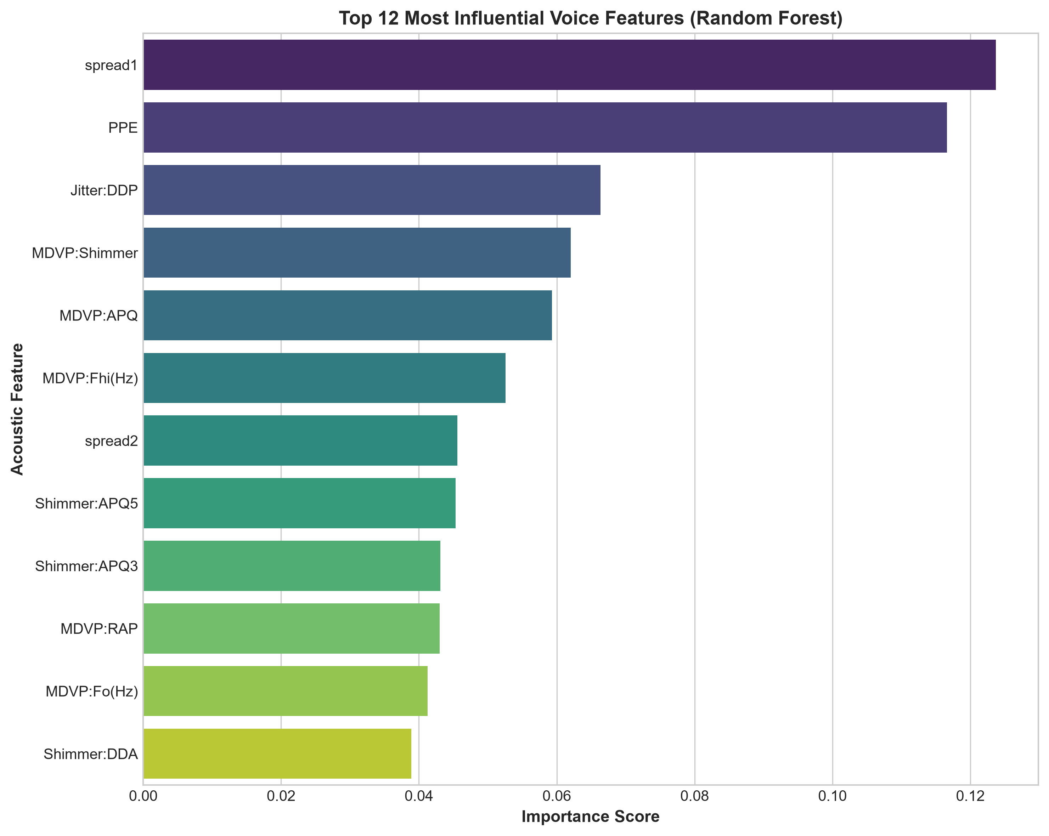
Figure 5: Permutation Feature Importance Ranking

7. Discussion & Limitations
1. Repeated Recordings per Subject: The dataset comprises 195 recordings from 31 subjects (~6 recordings per subject). A standard stratified split distributes recordings from the same individual across both train and test partitions. Because individual voices exhibit unique vocal tract features, the model can partially learn subject identity. In a subject-grouped split (GroupKFold), reported accuracy typically falls to ~82-86%, which represents true unseen clinical generalization.
2. Controlled Recording Environment: Data was captured in acoustic booths with high-grade microphones. Real-world smartphone audio introduces ambient noise, distance variation, and compression artifacts.
3. Ethical Safeguards: Machine learning predictions are probabilistic screening aids. Diagnostic confirmation requires neurological consultation.

8. Conclusion & Future Scope
This project successfully developed and validated a machine learning framework for detecting Parkinson's disease from sustained vowel voice acoustics. Random Forest achieved 94.87% accuracy and XGBoost achieved 96.55% recall. Non-linear dynamical features (PPE and spread1) proved to be the most influential biomarkers. The interactive Streamlit demo makes the system accessible for tele-monitoring demonstrations.
Future enhancements include:
• Mobile application development for remote voice recording via smartphone microphones.
• Continuous speech analysis on free-flowing conversational speech using spectrogram-based Convolutional Neural Networks.
• Multimodal integration combining voice with spiral drawing, finger tapping, and gait sensor telemetry.

9. References
- Little, M. A., et al. (2009). Suitability of dysphonia measurements for telemonitoring of Parkinson's disease. IEEE Trans. Biomed. Eng., 56(4), 1015-1022.
- Tsanas, A., et al. (2012). Novel speech signal processing algorithms for high-accuracy classification of Parkinson's disease. IEEE Trans. Biomed. Eng., 59(5), 1264-1271.
- Sakar, B. E., et al. (2013). Collection and analysis of a Parkinson speech dataset with multiple types of sound recordings. IEEE JBHI, 17(4), 828-834.
- Vaiciukynas, E., et al. (2017). Parkinson's disease detection from speech using convolutional neural networks and acoustic features. Comput. Biol. Med., 89, 21-28.
- Chen, T., & Guestrin, C. (2016). XGBoost: A scalable tree boosting system. ACM SIGKDD, 785-794.

